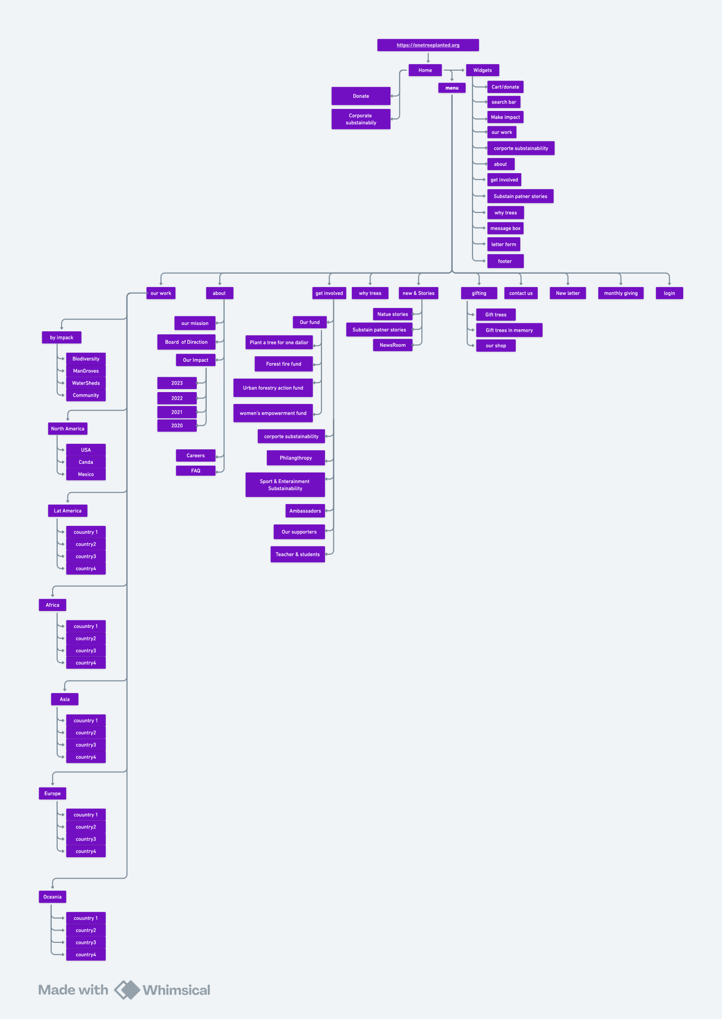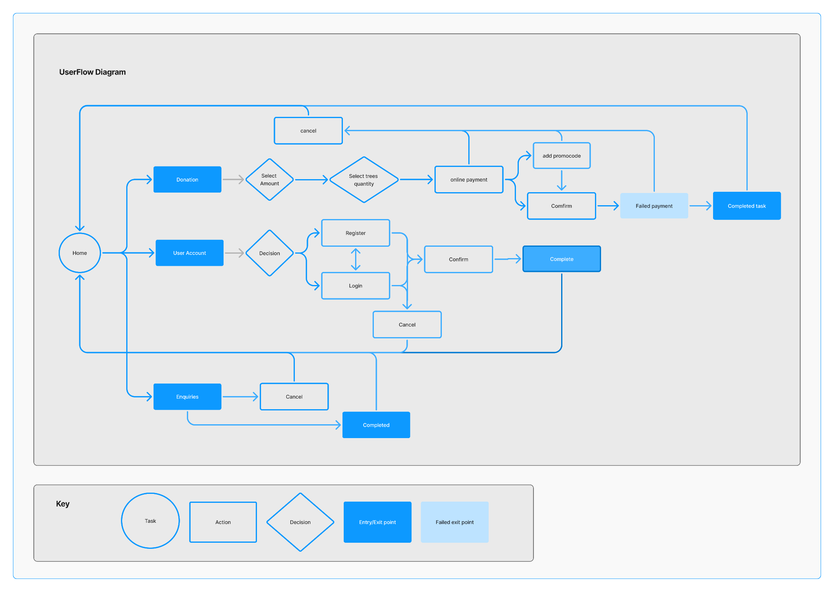

The sitemap outlines a hierarchical structure for a website, likely focused on **productivity and personal development**, with a strong emphasis on **goal setting** and **habit tracking**.

Here's a breakdown of the key areas:

* **Core Concept: The 12 Week Year**: This is a central theme, with dedicated sections explaining the concept, providing a roadmap, and offering resources. It suggests a system of achieving yearly goals in 12-week sprints.
* **Goal Setting & Planning**: This is a major category with various approaches and tools, including:
  + **Annual Planning**: Worksheets and processes for yearly planning.
  + **12 Week Year resources**: Specific tools for planning in 12-week cycles.
  + **Quarterly Planning**: Breaking down goals into 90-day segments.
  + **Monthly & Weekly Planning**: More granular planning for shorter timeframes.
  + **Daily Planning & Task Management**: Focus on daily actions and task organization.
  + **Goal Setting Methods**: Exploration of different goal setting frameworks.
  + **Vision & Values**: Guidance on defining personal vision and values.
* **Habit Tracking & Development**: A significant component, covering:
  + **Habit Trackers**: Tools for monitoring and tracking habits.
  + **Building Habits**: Strategies and techniques for habit formation.
* **Resources & Tools**: This section offers a variety of downloadable resources and tools, categorized by file type (spreadsheets, PDFs, etc.).
* **Community & Support**: Features like forums, masterminds, and coaching suggest a community aspect to the website.
* **About & Contact**: Standard pages providing information about the site and contact options.
* **Legal & Informational**: Terms of service, privacy policy, and disclaimer pages.
* **Blog & Podcast**: Content marketing efforts to provide valuable information and engage users.
* **Productivity & Time Management**: Broader topics covered, including:
  + **Procrastination**: Strategies for overcoming procrastination.
  + **Time Management**: Techniques for effective time allocation.
  + **Focus & Concentration**: Methods for improving focus and concentration.
* **Personal Development**: Includes areas like motivation, confidence, and mindfulness.

**Overall, the website appears to offer a comprehensive system and resources for personal development and productivity, centered around the "12 Week Year" concept. It caters to users interested in goal setting, planning, habit tracking, and overall self-improvement.** The presence of a community and various resources suggests a commitment to supporting users in their journey.